|  |  |  |  |  |  |  |  |  |
| --- | --- | --- | --- | --- | --- | --- | --- | --- |
|  | | | | | | | | |
|  | | **Cisco ASA 5505 Firewall lab configuration** | | | | |  | |
|  |  | | | | | | |  |
|  | | | |  |  | | | |
|  | | | | Weizhen Chen |  | | | |
|  | | | | —CCNP—Jeffery Mason &Michael Hansen |  | | | |
|  | | |  | | |  | | |

Purpose

The purpose of the lab is to do a SOHO configuration on a Cisco ASA router and access the console through ASDM Launcher.

Background information

Cisco Systems Incorporated is an American multinational digital communications technology conglomerate cooperation that created the concept of Local Area Networks. And makes products such as routers, switches, IP Phones, Firewalls, and more. Cisco ASA is a firewall created by Cisco Systems, ASA which is short for Adaptive Security Appliance. That while it reached the end of life, is still used by some enterprises to this day.

Lab commands

ASA (config)# configure factory-default [Sets Cisco ASA to factory default configuration]

Configurations

hostname ciscoasa

enable password 7fTgB/sKwfNkRaFs encrypted

names

interface Ethernet0/0

switchport access vlan 2

interface Ethernet0/1

switchport access vlan 1

interface Ethernet0/2

switchport access vlan 1

interface Ethernet0/3

switchport access vlan 1

interface Ethernet0/4

switchport access vlan 1

interface Ethernet0/5

switchport access vlan 1

interface Ethernet0/6

switchport access vlan 1

interface Ethernet0/7

switchport access vlan 1

interface Vlan1

nameif inside

security-level 100

ip address 192.168.1.1 255.255.255.0

interface Vlan2

nameif outside

security-level 0

ip address dhcp setroute

ftp mode passive

object network obj_any

subnet 0.0.0.0 0.0.0.0

pager lines 24

logging asdm informational

mtu outside 1500

mtu inside 1500

icmp unreachable rate-limit 1 burst-size 1

no asdm history enable

arp timeout 14400

no arp permit-nonconnected

object network obj_any

nat (inside,outside) dynamic interface

timeout xlate 3:00:00

timeout pat-xlate 0:00:30

timeout conn 1:00:00 half-closed 0:10:00 udp 0:02:00 icmp 0:00:02

timeout sunrpc 0:10:00 h323 0:05:00 h225 1:00:00 mgcp 0:05:00 mgcp-pat 0:05:00

timeout sip 0:30:00 sip_media 0:02:00 sip-invite 0:03:00 sip-disconnect 0:02:00

timeout sip-provisional-media 0:02:00 uauth 0:05:00 absolute

timeout tcp-proxy-reassembly 0:01:00

timeout floating-conn 0:00:00

dynamic-access-policy-record DfltAccessPolicy

user-identity default-domain LOCAL

http server enable

http 192.168.1.0 255.255.255.0 inside

no snmp-server location

no snmp-server contact

crypto ipsec security-association pmtu-aging infinite

crypto ca trustpool policy

telnet timeout 5

no ssh stricthostkeycheck

ssh timeout 5

ssh key-exchange group dh-group1-sha1

console timeout 0

dhcpd auto_config outside

dhcpd address 192.168.1.5-192.168.1.36 inside

dhcpd enable inside

threat-detection basic-threat

threat-detection statistics access-list

no threat-detection statistics tcp-intercept

class-map inspection_default

match default-inspection-traffic

policy-map type inspect dns preset_dns_map

parameters

message-length maximum client auto

message-length maximum 512

policy-map global_policy

class inspection_default

inspect dns preset_dns_map

inspect ftp

inspect h323 h225

inspect h323 ras

inspect rsh

inspect rtsp

inspect esmtp

inspect sqlnet

inspect skinny

inspect sunrpc

inspect xdmcp

inspect sip

inspect netbios

inspect tftp

inspect ip-options

service-policy global_policy global

prompt hostname context

Cryptochecksum:904dc8d24a80199b7ad5b92f93515224

: end

Setting ASA to factory default:

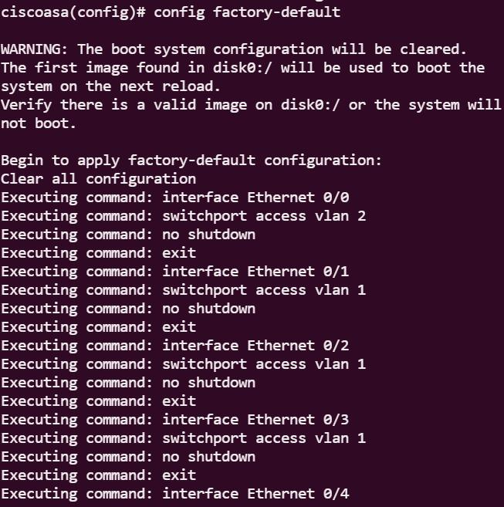

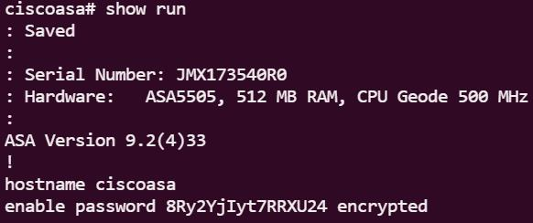

ASDM Launcher:

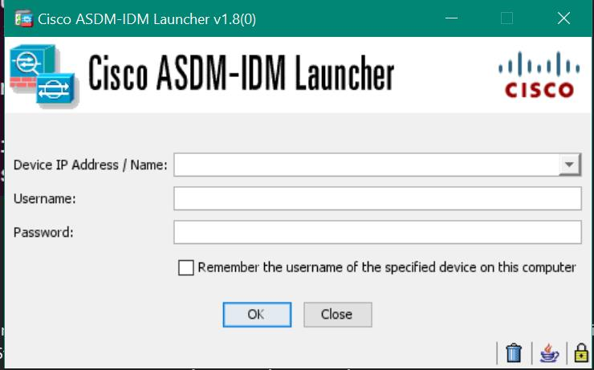

Problems

We did face a major problem that prevented us from completing the lab. Our main problem was we Had trouble accessing the firewall through Java Web Start and ASDM Launcher. While we couldn’t do it through Java Web Start, we managed to get it to work on ASDM Launcher by changing the shortcut properties and in Target we replaced it with “**C:\Windows\System32\wscript.exe invisible.vbs run.bat**”. Another problem we had was trying to get the Cisco ASA to work with ASDM Launcher, the ASDM launcher would not open. That was resolved by installing Java 8 runtime and uninstalling any installations of OpenJDK. But even with those issues resolved, we still couldn’t get ASDM launcher to work with the ASA.

Conclusion

The objective of the lab is to do a SOHO configuration on a Cisco ASA router and access the console through ASDM Launcher. Working in the lab allowed us to practice and familiarize ourselves with Cisco ASA routers. We managed to do a SOHO configuration on a Cisco ASA, but we couldn’t get ASDM launcher to work with the Cisco ASA.